Documentation of Webframe
Version: 1.0 from 1.Jan 2018

- Setup Environment
- Java 8
- Tomcat 8
- Eclipse IDE
- The following needs to be added to Tomcat VM arguments:
-Dsvnkitint.remote.url="SVN_LOCATION"
i.e -Dsvnkitint.remote.url="https://svn.riouxsvn.com/webframe/trunk/xmpl/"

“svnkitint.remote.url” is the SVN location where files should be committed to

- Authentication
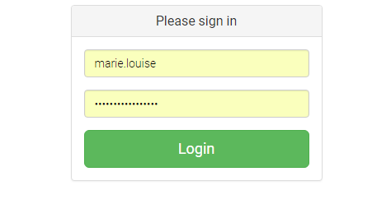
The user enters SVN username and password, the system authenticates the user and test connection to SVN specified in the “svnkitint.remote.url”
If success, redirects the user to the form page
If failure, displays error Invalid username or password

- Commiting to SVN
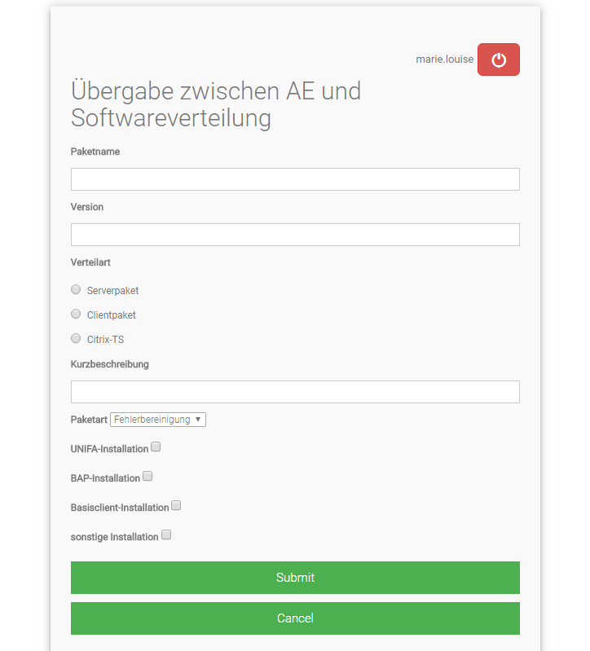

Packetname is required and is the filename
The user fills a form and clicks on submit button, the user inputs are transformed to the following format:
package=test
version=1.0.0
delivery= Serverpaket
comment=this is a test
packettype=Fehlerbereinigung
unifa=false
bap=true
basic=false
other=false
the inputs are saved on SVN specified in the “svnkitint.remote.url” in file called “test.properties”
if new file, message “First commit” is used as commit message
if file exists with the same name, message “File changed” is used as commit message

- Submit button: submits the form and commits user inputs on SVN
- Cancel button: reloads the page and discards user inputs
- Logout button: logouts the user

If success, page is reloaded and message Success! Your changes have been successfully committed. is displayed
If error, page is reloaded and message Success! Your changes could not be committed. is displayed

